
FOR IMMEDIATE RELEASE
March 18th, 2025
Contact: Chantal@epitaph.com
MAMALARKY

SHARE NEW SINGLE “ANHEDONIA”

NEW ALBUM HEX KEY OUT APRIL 11TH ON EPITAPH

Photo Credit: Vlonery

“Mamalarky is one of those groups driven by a tension between technical complexity and pop simplicity, a push-and-pull you can hear on this single from the upcoming album Hex Key. Skittish percussion and elastic bass lines provide a constantly shifting foundation for the lead singer Livvy Bennett’s wryly chiming vocals.”
-The New York Times

“Smartly doubles down on the proggy quirks and little incoherences that make them such a unique force while still maintaining the effortless charm of their previous music.”
-Pitchfork

“Mamalarky's brand of dazed indie-pop comprises songs that set a horizontal mood. Featuring Livvy Bennett and Noor Khan (who you may know as part of Faye Webster's live band) plus White Denim keyboard player Michael Hunter among its ranks, the band's debut is a lo-fi collection of songs to vibe out to, with layers of complexity”
-The FADER

“Hypnotic… The melody oozes and crawls like a body stuck to a hot blacktop, sounding as humid as it does tranquil."
-Paste

"A dazed two-minute sugar rush with blissed-out vocals and rushing breakbeats, and it sounds like something that Stereolab might’ve made if they were in a particularly jittery mood."
-Stereogum

“Atlanta-via-Austin freakbeat musos get funky, fuzzy and free-spirited on this extremely fun single from forthcoming third album.”
-The Quietus

Tri-coastal indie rock quartet, Mamalarky share “Anhedonia,” the latest from their recently announced new album, Hex Key, due April 11th on Epitaph Records. Hex Key is an intricate, endlessly curious album full of sonic left turns and playful genre implosions. On it Mamalarky expertly pastiche sounds, time signatures, and moods together to create delightful, singular songs bursting with feeling.

“‘Anhedonia’ is a song about feeling god awful. I was going through a really deep depression and not knowing what to do other than isolate myself from everyone,” Livvy Bennet explains. “I didn’t want to put this song out because of how much I associate it with pain and getting completely stuck in it. I’m glad it’s on the record now, though. The most defining times come after being at the bottom of the pit, every day passing the same. At some point you look up and anhedonia has gone and you’re more hopeful than before.”

Last month the band announced Hex Key with its high-octane and rambunctious lead single “#1 Best of All Time,” which received praise from The New York Times, Pitchfork, Paste, Stereogum, Brooklyn Vegan, Under The Radar, The Line Of Best Fit, The Quietus and more.

Mamalarky is Livvy Bennett, Noor Khan, Michael Hunter and Dylan Hill.

LISTEN TO “ANHEDONIA”

In making their third record, Hex Key, Mamalarky spent entire seasons hunched over guitars and obscure synthesizers, their long hair sweeping over strings or covering concentrated eyes. The band recorded takes in between the sounds of passing ice cream trucks and yowling stray cats in their Los Angeles home studio, a tight but prolific living room. Hex Key is a document of perseverance, of going for the gold while somehow remaining totally aware of one’s own vulnerabilities. These effervescent, swirling songs chronicle vivid desires crashing against real-life limitations but finding a way to keep burning anyway. That tension between anguish and resilience, between performed aloofness and brutal honesty, drives the music, imbues it with a compelling intensity.

Given their closeness, Mamalarky are able to fight like family, not necessarily with each other, but for the music, to make it the best it can be. Whereas their last album, Pocket Fantasy, was exploratory and free-flowing, the songs on Hex Key are the result of absolute devotion and fine-tuning. It’s the kind of attention to detail that can only happen when the four bandmates are working alone together, uninterrupted by producers, engineers, or any outside influences. “It’s never ‘kick your feet up, let’s see what happens,” guitarist and singer Livvy Bennett says. “We’re always staring each other deeply in the eyes saying ‘Let’s make this next take incredible.’ We never settle.” The band is so committed to their craft that Hill even recorded the drums for “#1 Best of All Time” amidst an intense bout of poison ivy. The determination he felt in the moment manifested itself in the song’s frantic but focused percussion, he says.
Mamalarky is intentional about ensuring the sonic diversity of their projects. “The worst thing you can say about a Mamalarky song is ‘This sounds like another song of yours,’” bassist Noor Khan says. It’s what distinguishes them from a lot of indie rock bands who prioritize sonic consistency throughout an album. On Hex Key, each song is a world of its own.
LISTEN TO PREVIOUSLY RELEASED SINGLES
“#1 BEST OF ALL TIME,” “NOTHING LASTS FOREVER,”
& “FEELS SO WRONG”

A feeling of determination permeates throughout the record. The first song Mamalarky wrote for the album was “Feels So Wrong.” Throughout the track, they oscillate between lamenting deep seeded feelings of inauthenticity while also reassuring themselves that everything will work out. While writing the album, Bennett had just quit her job, moved to Los Angeles from Atlanta, and was delivering pizza via Uber Eats. Around this time, Bennett and keyboardist Michael Hunter also started producing for other artists out of their home studio. The experience led to further genre-bending in their own work and pushed them to make more music than they ever had before. “I was writing some of my favorite music ever, but it didn’t feel how I expected it to,” she says. “I still didn’t have it all figured out. So I wrote songs like ‘Feels So Wrong,’ and ‘#1 Best of All Time’ as a way of telling myself what I needed to hear.”
As much as the music is meant to be reassuring, it also honors confusion rather than quelling it. Hex Key often acknowledges the inherent discomforts to being alive - self-doubt, romantic yearning, feeling out of place in your own skin - and embodies the anger this dysphoria ignites. “A lot of this record is about reconciling with rage, finding a way to create something useful with it,” Bennett says. “You can’t really talk yourself out of a feeling, but there’s always a good place to put them.”
While working and reworking the songs on Hex Key, the bandmates would often go on an intense hike near Bennett’s home. “We would be getting our heart rate up while we figured out the details of the record,” Bennett says. “I would be like, ‘I think we need to re-record the guitar. And the chorus needs to have some sort of lift happening.’ And then, once we would get up to the top of the mountain, we would see this really beautiful pond. It was somehow always reassuring.” The songs on Hex Key are a document of that uphill scramble. Throughout the record, Mamalarky confronts their messiest emotions, turning them into high-octane musical compositions that twist furiously and blaze fluorescent. Whether or not they reach the top is almost irrelevant when the process of getting there is so beautiful to observe.

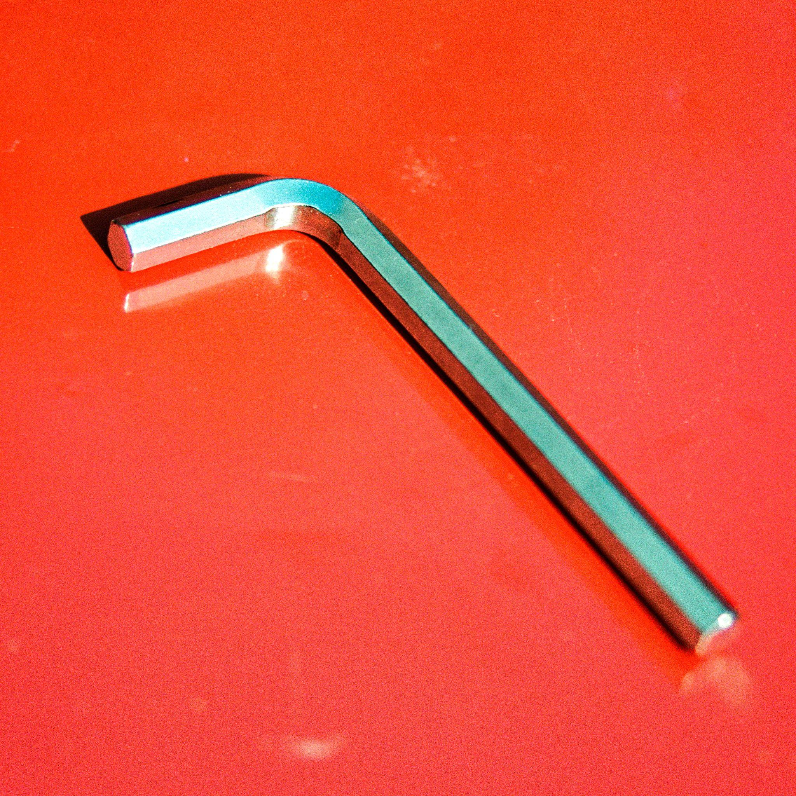
Hex Key Album Art

1. Broken Bones
2. Won’t Give Up
3. The Quiet
4. Hex Key
5. Anhedonia
6. #1 Best of All Time
7. Take Me
8. MF
9. Blow Up
10. Blush
11. Nothing Lasts Forever
12. Feels So Wrong
13. Here’s Everything

WEBSITE | BANDCAMP | SPOTIFY | APPLE MUSIC
YOUTUBE | INSTAGRAM | TWITTER | FACEBOOK

Mamalarky Press Contact
Chantal Neeten | Epitaph Records | chantal@epitaph.com

