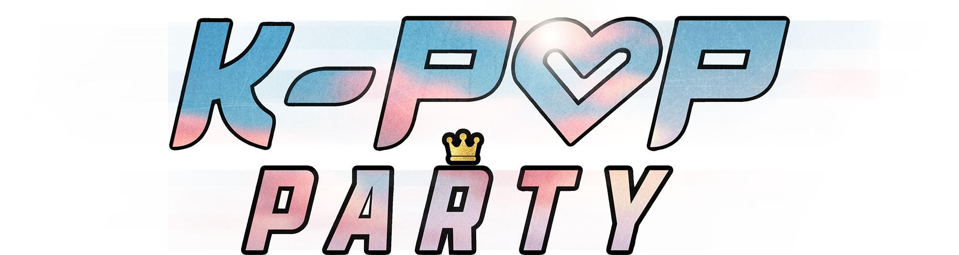

The UK’s first touring K-POP show!
🎤 Get ready to sing, dance, and party like never before at K-POP PARTY – the ultimate live concert experience celebrating Korea’s global music phenomenon!
🔥 Packed with the BIGGEST hits and fan-favourite tracks from the smash-hit film K-POP DEMON HUNTERS 🗡️💫 this high-energy, family-friendly show brings the world of K-pop to life. Electrifying performances, iconic choreography, and non-stop music from your favourite K-POP ICONS.
🎶 Featuring songs from BLACKPINK, ROSÉ, BTS, TWICE, K/DA, KATSEYE, and DEMON HUNTERS groups SAJA BOYS and HUNTR/X. This party show is for all ages whether you’re a hardcore fan or brand new to the K-Pop wave.
✨ The lights are up. The stage is set. It’s your time to shine like you’re born to be. Make the Honmoon Golden at the K-POP PARTY! 💜
—------
UK TOUR DATES 2026
FEBRUARY
15 - The King's Hall, Herne Bay
17 - Theatre Royal, Wakefield
18 - New Wolsey Theatre, Ipswich
19 - Playhouse, Harlow
20 - Bacon Theatre, Cheltenham
21 - Eric Morecambe Centre, Harpenden
22 - Swan Theatre, Worcester

APRIL
06 - Palace Theatre, Watford
07 - Camberley Theatre, Camberley
08 - Roses Theatre, Tewkesbury
09 - Yvonne Arnaud, Guildford
10 - The Point, Eastleigh
11 - Radlett Centre, Radlett
12 - Charter Hall, Colchester
13 - Alive Corn Exchange, King's Lynn
14 - New Theatre, Hull
15 - Playhouse, Alnwick
16 - Albert Halls, Bolton
18 - McMillan Theatre, Bridgwater
19 - The Ffwrnes, Carmarthen

MAY
22 - Garrick Playhouse, Altrincham
23 - Majestic Theatre, Retford
24 - Civic Theatre, Rotherham
25 - Tyne Theatre & Opera House, Newcastle
26 - Queen's Hall Arts Centre, Hexham
28 - Brewhouse Theatre, Taunton
29 - Royal Hippodrome Theatre, Eastbourne
30 - Arts Centre, Haverhill
31 - Marina Theatre, Lowestoft

JULY
04 - West Cliff Theatre, Clacton-on-Sea

OCTOBER
26 - Broadway Theatre, Letchworth
27 - Blackwood Miners' Institute, Blackwood
28 - Benn Hall, Rugby

