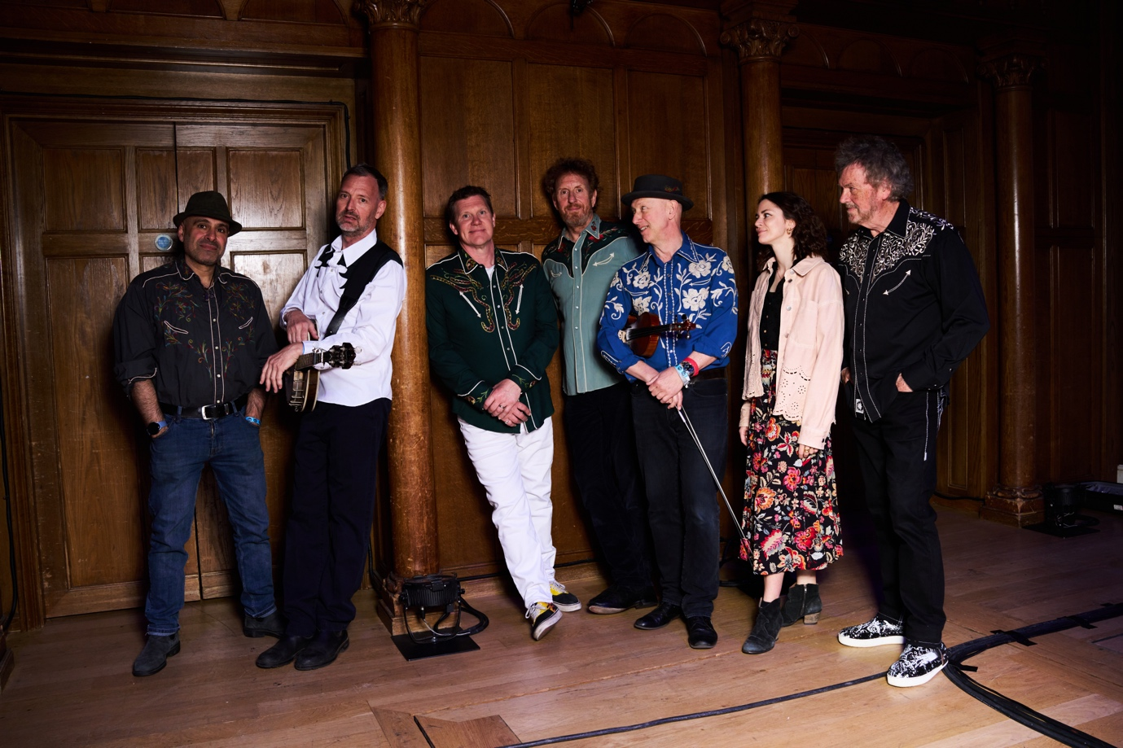

After touring their last Album LIGHTNING STRIKE through the winter of 2024/25 and supporting their acclaimed RNLI 200 Christmas single ‘Pull Away’, POLICE DOG HOGAN set to work finishing their new album, to be called THE LIGHT AT THE TOP OF THE STAIRS, slated for release in early 2026

The autumn of 2025 sees POLICE DOG HOGAN back out on the road promoting 7 KINDS OF RAIN, the first single drawn from the new album. This will be followed by a much more extensive UK tour in spring 2026.

This is the most complete, personal and emotional record yet from Police Dog Hogan. The collective musical skills of the band have been used to full effect to create an album that delivers on both interpretation and atmosphere as they muse on the need to grab life by the throat as time becomes ever more precious.

Police Dog Hogan, first formed in 2009, has evolved over the years into a tight-knit seven-piece band combining guitar, fiddle, banjo, mandolin, accordion, trumpet, keyboards, bass and drums to create an exuberant fusing of country, pop, folk and rocking bluegrass. They’ve been described as ‘pop music with all the wrong instruments’ by some, Brit - Americana by others and a ‘seven headed joy machine’ by all who witness the show as PDH cover the spectrum of all human emotions from hilarity with ‘ Three Drinks A Day’ to profound and tear stained with ‘One last Trip Around The Sun’.

Police Dog Hogan, with at least 400 shows under their belts now, are a regular fixture on the UK festival circuit, having played Glastonbury, Cornbury, Cropredy, Latitude, Beautiful Days, Black Deer and the Sidmouth and Shrewsbury Folk Festivals in recent years.

In 2018 their song Devon Brigade was nominated for best original song at the AMA-UK Awards. Their most 2022 album Overground, produced by George Murphy at Eastcote Studios, yielded cult favourites Westward Ho! And Hold On.

They have gained a reputation for fine Christmas singles. The first raised in excess of £60,000 for Crisis in 2020. Most recently Pull Away celebrated the RNLI’s 200th birthday in 2024 In London they have sold out the Shepherds Bush Empire, Scala, Union Chapel, Cadogan Hall and the Clapham Grand in the last few years.

POLICE DOG HOGAN are:

James Studholme Guitar and singing
Tim Dowling Banjo, Guitar and singing
Edward Bishop Fiddle, mandolin and singing
Shahen Galichian Accordion, Piano, harmonica and singing
Don Bowen Bass and singing
Al Hamer Drums and singing

