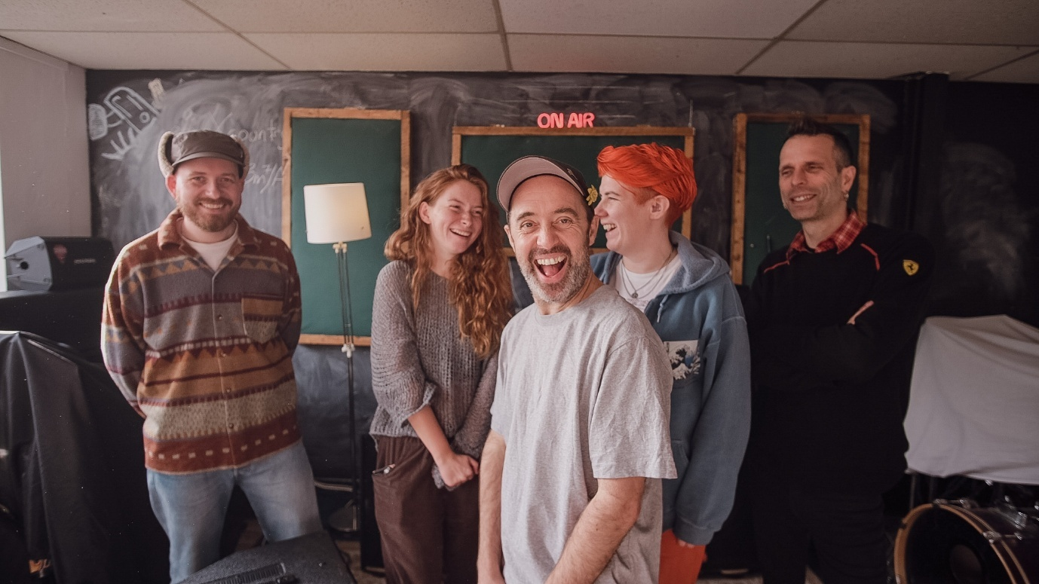
BEANS ON TOAST ANNOUNCES NEW ALBUM ‘KILL THEM WITH KINDNESS’ TO BE RELEASED DECEMBER 1ST VIA BOTMusic
FULL BAND TOUR ANNOUNCED FOR MARCH 2026
TICKETS AVAILABLE HERE
PRE-ORDER THE ALBUM HERE
Essex-born folk troubadour Beans on Toast has been charming audiences with his candid songwriting and engaging live performances for nearly two decades. Blending humour, politics, and storytelling, he has built a dedicated fanbase through constant touring, playing festivals across the globe and packing out venues big and small, whilst adding to a vast and varied discography that celebrates life and the human spirit with raw honesty, warmth, and wit.
His legendary live shows are unpredictable and full of heart, where the line between artist and audience disappears, and every gig, whether a heaving festival crowd or an intimate backroom gig, feels like a wild night with an old friend.
Recorded at Greenmount Studios in Leeds with The Beans on Toast Band, the new album titled ‘Kill Them With Kindness’ is due for release December 1st via BOTMusic and features a collection of insanely talented musical friends hand-picked from the UK music and festival scene.
“We've done a few tours together, but this was our first venture into a studio. Each one of them is amazing, and together... well, I'm proper chuffed with how it sounds,” Beans on Toast explains. "This album is a bit of a juxtaposition, as is the title. There are songs that deal with the current state of the world. Wars, maniac leaders, the rise of AI and the fall of the establishment. Then there are songs about trees, late nights in music venues, art, love and my new cat. As usual, it's a time stamp of my thoughts and feelings from the past year on planet Earth.”
Beans on Toast hits the road with his full band in March 2026, tickets available HERE
The first single from the album, titled ‘Glastonbury Oak’, will be released Oct 3rd.
The new record is up there with his finest work to date, bouncing between songs about the shitshow of planet earth and the fall of the establishment, to family life, planting trees, and the absurdities of modern living.
Expect songs, stories, chaos and community in equal measure.
‘Kill Them With Kindness’ track-listing:
1.The Great North Road
2. Gods, Children and Robots
3. Comfortable in the Counterculture
4. Pelican Crossing
5. The Fall of the Establishment
6. The Glastonbury Oak
7. A Real Rock n Roller
8. Big Night out in Shrewsbury
9. That’s why I don’t drink Tequila Anymore
10. Taylor Swift for President
11. Our Cat
12. Happy Birthday Baby
13. Magicians and Outlaws
Pre-order the album HERE:
The Beans on Toast Band are:
Abbi Phillips - Drums
Bassie Gracie - Bass
King Killership - Keys
Memphis Gerald - Guitar
Ryth Lyon – Fiddle
Catch The Beans on Toast Band on tour in March 2026 at the following dates:
March
4 SHEFFIELD - Sidney & Matilda
5 NEWCASTLE - The Cluny
6 GLASGOW - Stereo
7 LEEDS - Brudenell Social Club
11 BIRMINGHAM - Hare & Hounds
12 BRISTOL - The Fleece
13 CARDIFF - Clwb Ifor Bach
14 MANCHESTER - Band on the Wall
18 EXETER - Phoenix
19 SOUTHAMPTON - The Brook
20 BRIGHTON - Concorde 2
Solo gigs already announced for 2025:
November
12 BEDFORD - Esquires
13 HITCHIN - Club 85
14 STOWMARKET - John Peel Centre
15 NORWICH - Norwich Arts Centre
16 LEEK - Foxlowe Arts Centre
18 STOCKTON - The Georgian Theatre
19 CARLISLE - The Brickyard
20 DUNDEE - Beat Generator
21 LANCASTER - Kanteena
22 MOSSLEY - The Vale
23 WHITBY - Whitby Brewery
24 CHESTER - The Live Rooms
25 HEBDEN BRIDGE - The Trades Club
27 NUNEATON - The Queens Hall
28 SHREWSBURY - Albert's Shed
29 DONCASTER - Wroot Rocks
30 GRIMSBY - Docks Academy
December
3 DERBY - The Old Bell Hotel
4 GLASTONBURY - The King Arthur
5 NEWPORT - Corn Exchange
6 WORCESTER - St Swithun's church
7 READING - Facebar
9 PORTSMOUTH - The Wedgewood Rooms
10 TOTNES - The Barrel House Ballroom
11 PENZANCE - The Acorn
12 GUILDFORD - Boileroom
13 RAMSGATE - Ramsgate Music Hall

